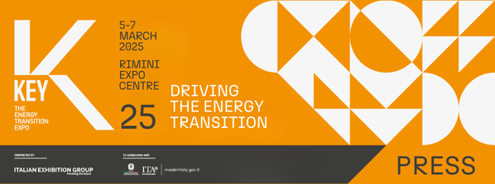

press release
(English translation)

ITALY, KEY - THE ENERGY TRANSITION EXPO STARTS TOMORROW
AT RIMINI EXPO CENTRE WITH MINISTER PICHETTO FRATIN
- The inauguration will also be attended by Maurizio Ermeti, President of Italian Exhibition Group, Michele De Pascale, President of the Emilia-Romagna Region, Anna Montini, Rimini City Councillor for Ecological Transition, and Paolo Arrigoni, President of GSE
- Until 7th March at Italian Exhibition Group's Expo Centre, over 1,000 exhibitors and about 350 hosted buyers and international delegations for the largest edition ever

Rimini (Italy), 4th March 2025 - The curtain is about to rise on the exceptional energy transition and efficiency stage. As of tomorrow, Wednesday 5th and until Friday 7th March, Rimini Expo Centre will be hosting KEY - The Energy Transition Expo, the IEG (Italian Exhibition Group) event of reference in Europe, Africa and the Mediterranean basin dedicated to the future of energy.

More than 1,000 exhibitors are expected (20% more than in 2024), of which over 30% will be international. Thanks to the support of the Ministry of Foreign Affairs and International Cooperation (MAECI) and the Italian Trade Agency (ITA), collaboration with the leading sector Associations and a worldwide network of agents, about 350 hosted buyers and delegations from more than 50 countries will be involved with North Africa, the Middle East, the Balkans and Eastern Europe the areas most represented.

THE FIRST DAY
Scheduled for 12 noon on the Main Stage of the Lorenzo Cagnoni Dome in the South Hall, the Opening Ceremony with the Minister for the Environment and Energy Security Gilberto Pichetto Fratin will take place. Speakers will include Maurizio Renzo Ermeti, President of Italian Exhibition Group, Michele De Pascale, President of the Emilia-Romagna Region, Anna Montini, Rimini City Councillor for Ecological Transition (Environment, Sustainable Development, Planning and Care of Public Green Areas), Blue Economy and Statistics, and Paolo Arrigoni, President of GSE.

Also tomorrow, at 2.45 pm on the Main Stage, the KEY ENERGY SUMMIT, opened with the institutional greetings of Corrado Peraboni, CEO of IEG, and an introduction by Gianni Silvestrini, president of KEY’s Technical-Scientific Committee. Alessandro Marangoni will present the Althesys study entitled “Decarbonisation and competitiveness, from European policies to Italian industry. Strategies for a sustainable energy transition aimed at growth”, followed by panel discussions on “The Associations proposals”, with the participation of Assoesco, FIRE, H2IT, Coordinamento FREE, Motus-E, Elettricità Futura, ANIE, Federidroelettrica, ANEV and Italia Solare. Final reflections will be entrusted to Paolo Arrigoni, president of GSE, and Gilberto Pichetto Fratin, Minister for the Environment and Energy Security.

This will be followed at 5 pm by the presentation of the Lorenzo Cagnoni Innovation Award to the three Innovation District start-ups whose projects particularly stood out, and the seven exhibitors presenting the most avant-garde projects at KEY, one for each of the event's product sectors.

The 2025 edition of KEY will be the largest ever, confirming its transversal and integrated vision across multiple sectors and technologies, which sets it apart from all other European events dedicated to energy. The show consolidates its role as a reference network for the global energy transition and efficiency community, capable of favouring encounters and discussions between all the stakeholders involved and interlocution with the institutions with the aim of creating a system and contributing to the identification of shared solutions to speed up decarbonisation.

KEY is also a proven privileged opportunity for companies wishing to rationalise their consumption, control energy costs, reduce the energy and environmental impact of their activities and learn about the latest innovations and technologies available on the market.

THE NEW LAYOUT AND EXHIBITION FOCUSES
The layout has been totally redesigned to meet the requirements of an ever-growing exhibition without the need for further readjustments in the future. For the first time, the new layout will include a fair balance on both wings (East and West) of the exhibition centre, with the unprecedented opening of the West Entrance, in addition to the South and East Entrances. A total of 20 halls (4 more than in 2024) on 90,000 m² of floor space, divided into seven themed areas, one for each of the seven product sectors: photovoltaics, wind energy, hydrogen, energy efficiency, energy storage, e-mobility and Sustainable City.
Innovations will include the hydrogen area’s expansion into the new HYPE – Hydrogen Power Expo supported by Hydrogen & Fuel Cells area, jointly organised by Italian Exhibition Group and Hannover Fairs International GmbH (HFI), the Italian branch of Deutsche Messe AG.
Also making its debut will be Su.port - Sustainable Ports for Energy Transition, an exhibition focus on port dock electrification, which is essential for reducing emissions in the maritime sector, promoting sustainability in ports, and accelerating the development of off-shore wind power, particularly floating.
The area dedicated to energy efficiency in Hall A5 will also feature a space for KEY’s new partner Federcostruzioni, the Confindustria Federation representing the Italian construction industry.

ABOUT KEY 2025
Event: International trade show; Organizer: Italian Exhibition Group S.p.A.; Frequency: annual; Edition: 3rd; Dates: 5-7 March 2025; mail keyenergy@iegexpo.it; Website: http://www.key-expo.com; Facebook: https://www.facebook.com/keyexpo/; Instagram: https://www.instagram.com/key_expo/; LinkedIn: https://www.linkedin.com/company/keyenergy/

PRESS CONTACT KEY - ITALIAN EXHIBITION GROUP
head of media & corporate communication: Elisabetta Vitali; press office manager: Marco Forcellini, Pier Francesco Bellini; international press office coordinator: Silvia Giorgi; press office coordinator: Luca Paganin; press office specialists: Nicoletta Evangelisti, Mirko Malgieri; media@iegexpo.it

MEDIA AGENCY: Smartitaly Communications
Sara Scatena, s.scatena@smartitaly.it, mob. +39 338 7836985; Arianna Geli, a.geli@smartitaly.it, mob. +39 347 0917903

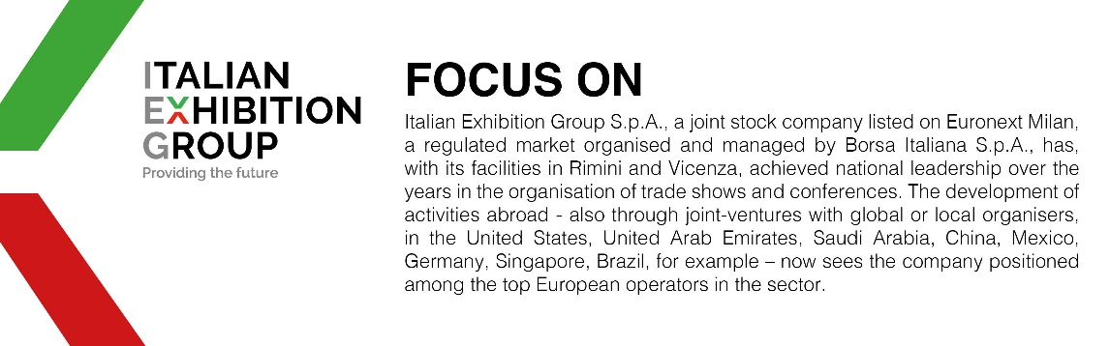

This press release contains forecast elements and estimates that reflect the management’s current opinions (“forward-looking statements”), particularly regarding future management performance, realization of investments, cash flow trends and the evolution of the financial structure. For their very nature, forward-looking statements have a component of risk and uncertainty, as they depend on the occurrence of future events. The effective results may differ (even significantly) from those announced, due to numerous factors, including, only by way of example: food service market and tourist flow trends in Italy, gold and jewellery market trends, green economy market trends; the evolution of raw material prices; general macroeconomic conditions; geopolitical factors and evolutions in the legislative framework. Moreover, the information contained in this release does not claim to be complete, and has not been verified by independent third parties. Forecasts, estimates and objectives contained herein are based on the information available to the Company as at the date of this release.

